EXP NO 2:

Create a simple cloud software application for Students Attendance System using any Cloud Service Provider to demonstrate SaaS include the necessary fields such as name of the students, course, present, Absent, course attendance, OD request, grade, attendance percentage, etc.

DATE:

AIM:

To Create a simple cloud software application for Student Attendance System using any Cloud Service Provider to demonstrate SaaS.

PROCEDURE:

Step1: Go to zoho.com.

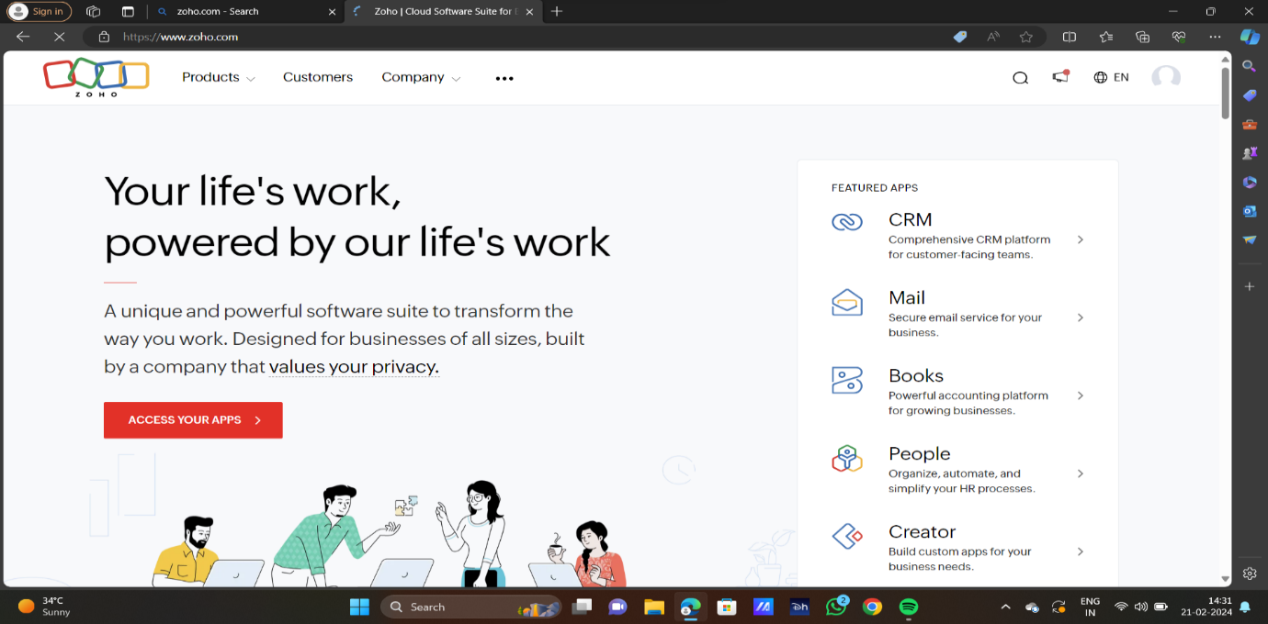

STEP2:LOG INTO THE ZOHO.COM

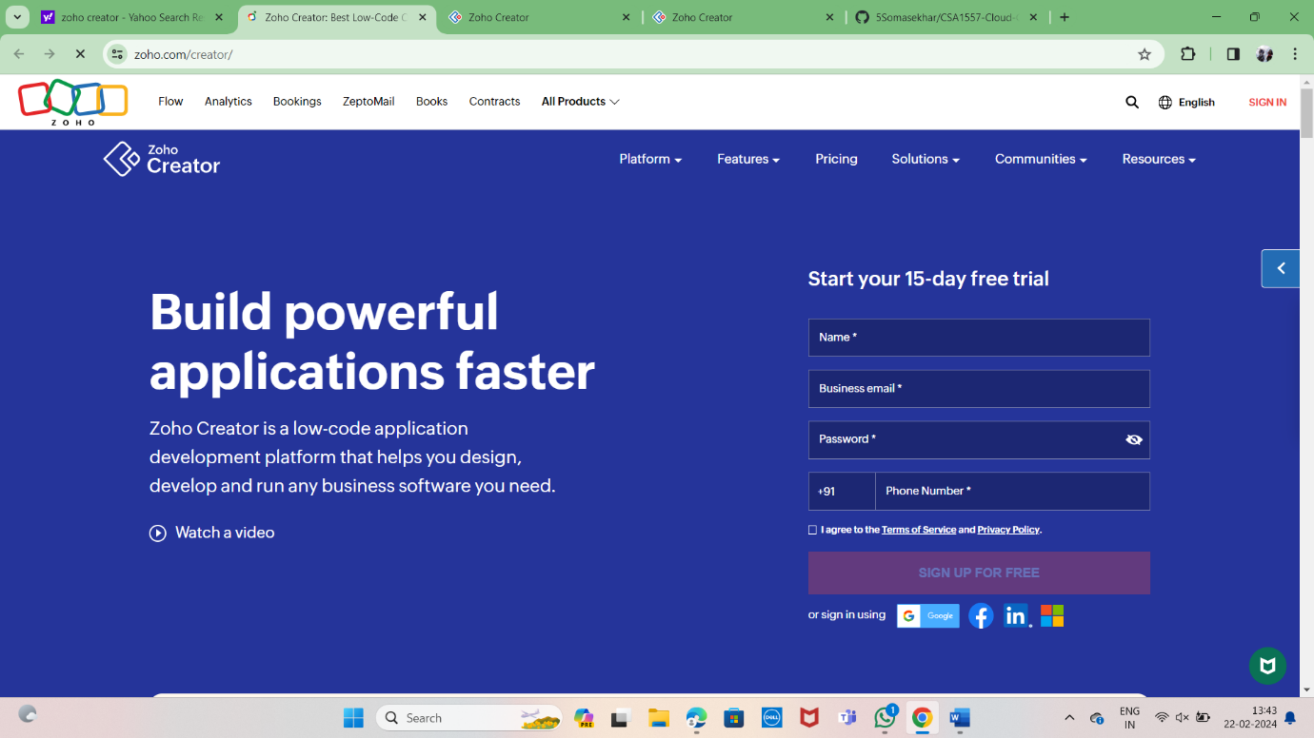

STEP3: SELECT ONE APPLICATION

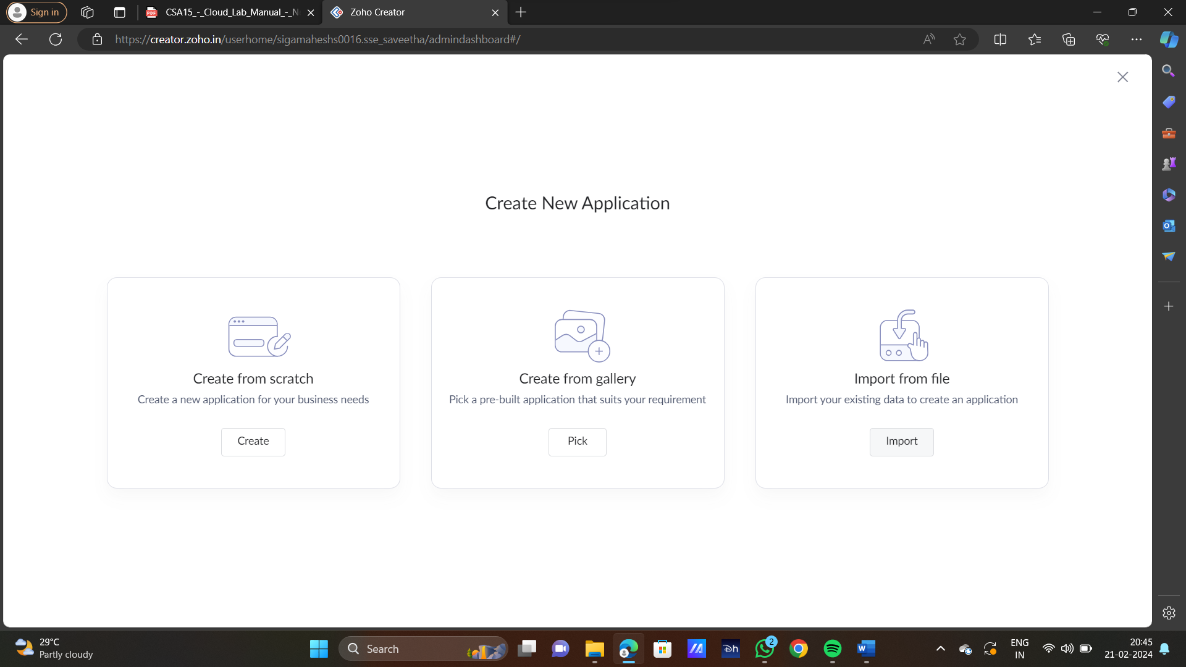

STEP4: ENTER APPLICATION NAME

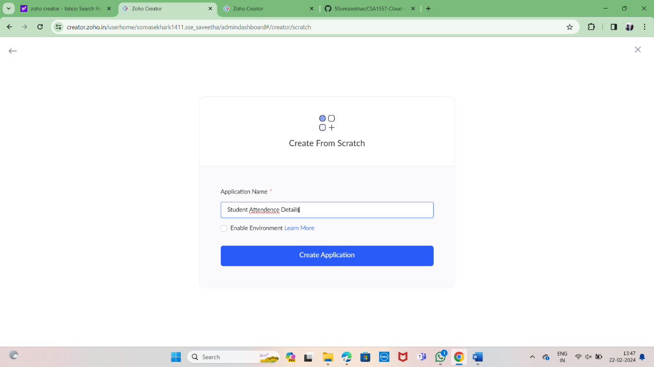

STEP5: CREATED NEW APPLICATION

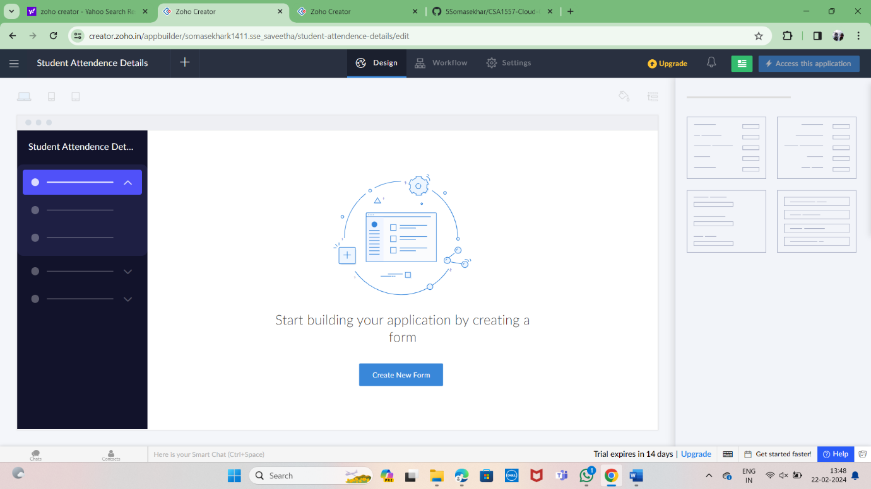

STEP 6: SELECT ONE FORM

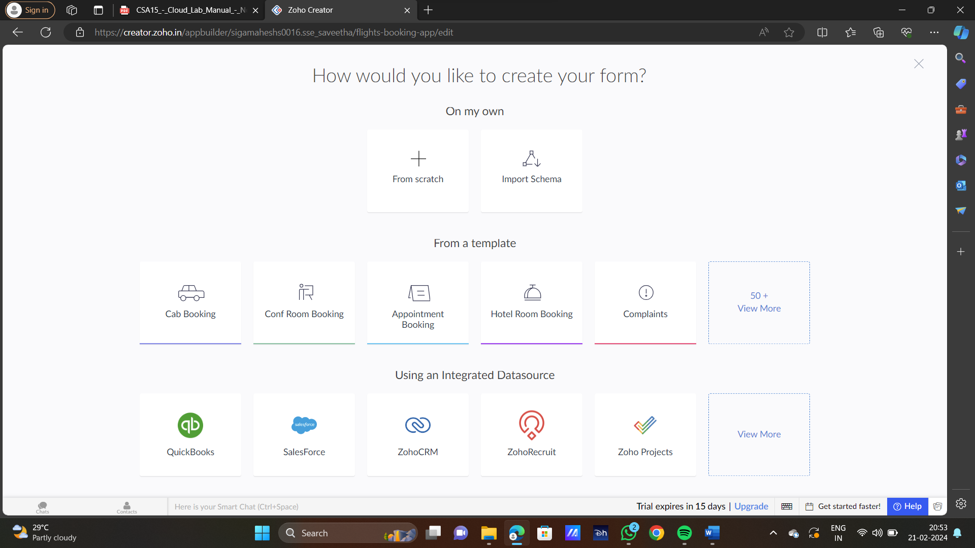

STEP 7: THE SOFTWARE HASE BEEN CREATED.

